Question 6

Title: Inter-AS Routing Simulation with NS-3: BGP and Multi-Provider WAN Modeling

1. Introduction
- Overview of inter-domain routing and the role of BGP.
- Context of multi-provider WANs and Autonomous Systems (AS).

Objectives of this simulation:
- Model AS65001 and AS65002.
- Implement basic BGP path selection.
- Simulate route leaks.
- Compare simulation vs real-world BGP.

2. Modeling Autonomous Systems in NS-3

2.1 Logical Grouping of Nodes
- Use containers or vectors to represent AS65001 and AS65002.
- Each AS includes routers, hosts, and internal links.

2.2 Internal Routing (OSPF/static)
- Each AS uses IGP (e.g., static routing) isolated from others.
- Prevent routing leaks by scoping routes within AS boundaries.

2.3 Peering Links (IXP-A and IXP-B)
- Assign specific routers as border routers.
- Connect ASes using point-to-point links.
- Configure BGP announcements only at these border points.

Diagram: Topology showing two ASes, internal links, and peering at IXPs.

3. BGP Route Attributes Simulation

3.1 Data Structure (C++ Style)

```cpp
struct BgpRoute {
Ipv4Prefix prefix;
std::vector<uint32_t> asPath;
uint32_t localPref;
uint32_t med;
};
```

3.2 Path Selection Logic
- Priority: LOCAL_PREF > Shortest AS_PATH > MED
- Loop prevention via AS_PATH inspection.
- Table comparing multiple routes to the same prefix.

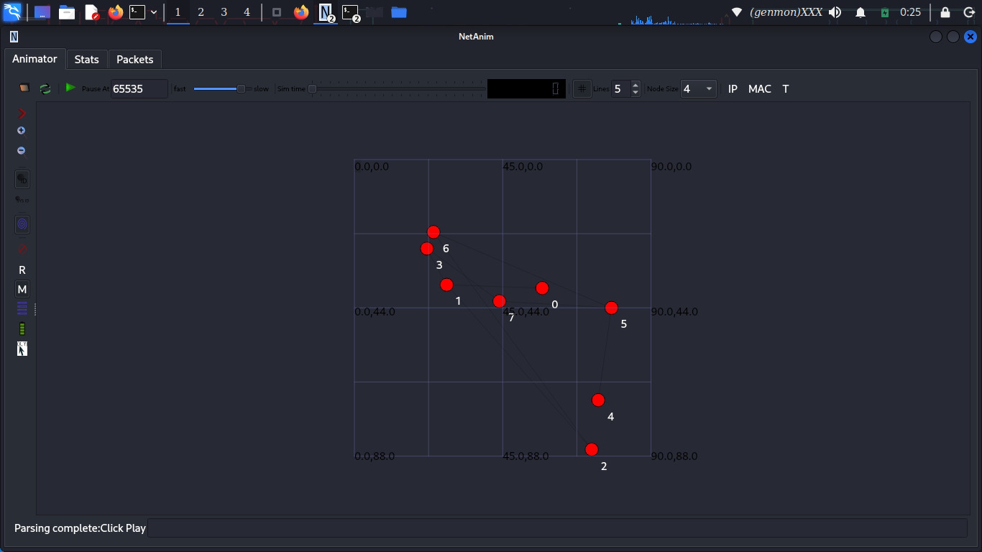

4. BGP Decision Algorithm
4.1 Pseudocode
- Receive update → check loop → compare attributes → update table → forward best route.

4.2 Explanation
- Use simplified forwarding table.
- Announcements propagated only when routes change.

5. Simulating a Route Leak
5.1 Scenario Description
- AS65002 advertises AS65001’s prefix (maliciously or accidentally).
- AS_PATH: [65002, 65001] → loop detected by AS65001.

5.2 Simulation Setup
- Inject route at a border router with wrong AS_PATH.
- Observe whether AS65001 accepts or rejects.

5.3 Reaction
- With loop detection → reject.
- Without loop detection → may accept (bad route).

6. From Simulation to Reality

6.1 Simplifications in NS-3
- No TCP sessions (BGP normally runs over TCP).
- No route timers, keepalives, soft reconfiguration.
- Limited policy-based routing or advanced features.

6.2 Missing BGP Features

Feature | | Why Difficult in NS-3
| Route Reflectors | Needs complex mesh/topology logic
Communities | Requires flexible tagging & policy handling
RPKI / BGPsec | Needs cryptographic modules and validation

6.3 Suitability of NS-3
- Good for academic/testing use.
- Limited for production-scale realism.

7. Conclusion
- NS-3 can model basic BGP logic across ASes.
- It helps understand path selection and routing dynamics.
- However, it lacks support for full BGP complexity and is better for educational simulations.

8. References
- Kurose & Ross, *Computer Networking: A Top-Down Approach*
- Cisco Blogs – WAN and BGP configuration
- RFC 4271 – BGP-4 Specification
- NS-3 documentation

